Amazon_Sales_Analysis

World's largest and most diverse technology company Amazon. With a vast portfolio spanning e-commerce, cloud computing, streaming, and more, Amazon's sales play a pivotal role in the global marketplace. This report offers a comprehensive analysis of Amazon's sales, with a focus on key revenue drivers, regional performance, and emerging trends. By dissecting Amazon's sales data, we aim to gain valuable insights into the company's financial health and market positioning, providing crucial information for various stakeholders. The analysis draws on a variety of financial reports, historical data, and market intelligence.



Projects_Objectives:

**Product Category Insights**: To gain a deep understanding of which product categories are driving sales and growth, and which might need strategic focus.

**Customer Behavior:** To analyze customer buying behavior, including preferences for product sizes and types, and to identify patterns in repeat business.

**Geographical Analysis:** To examine sales trends across different regions or countries, helping identify key markets and areas of potential expansion.

Assumptions:

Customer Behavior: Assuming that customer buying behavior in the past will continue into the future.

Customer Satisfaction**:** Assuming that customer reviews and feedback accurately represent overall customer sentiment and satisfaction.

Hypothesis :

Seasonal Trends - Amazon's sales performance exhibits significant seasonality, with increased sales during peak shopping seasons.

Customer Behavior and Loyalty - There is a connection between customer behavior, such as repeat purchases and product reviews, and overall sales growth.

Product Category Performance - Certain product categories (e.g., tshirt,shirt socks) contribute disproportionately to Amazon's overall sales revenue.

Analysis And Findings:

Count plot of various size

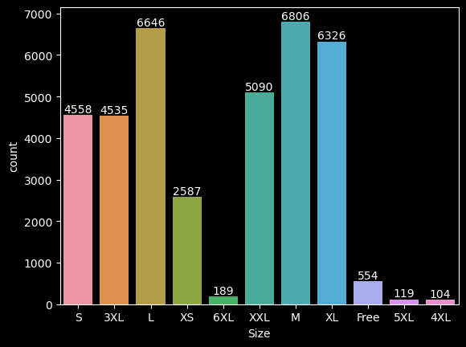

The "Count and Size" graph, it's shows that M-size clothing is the most preferred by customers. This finding suggests a clear market trend toward medium-sized clothing items. To capitalize on this trend, businesses should prioritize the availability and promotion of M-sized products, potentially boosting sales and customer satisfaction.

Barplot of quantity (Qty) and Size

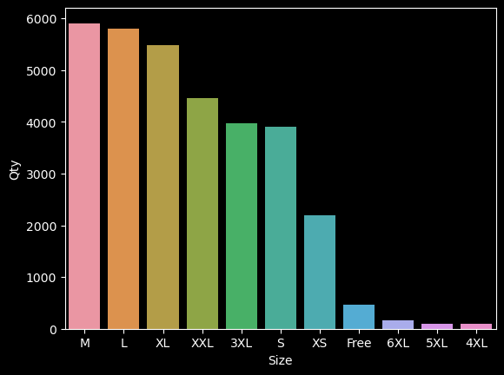

The data strongly suggests that prioritizing the M-sized clothing category is essential for aligning supply with customer demand.

Graph of courier status

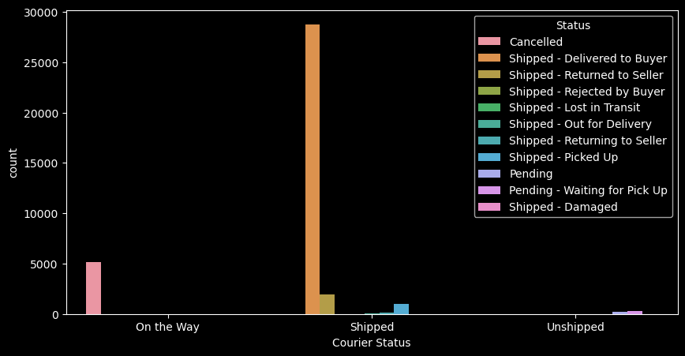

Delivery performance is a vital aspect of customer experience, and the data demonstrates a clear area of strength in the "Delivered to Buyer" category.

From above Graph the majority of the orders categories

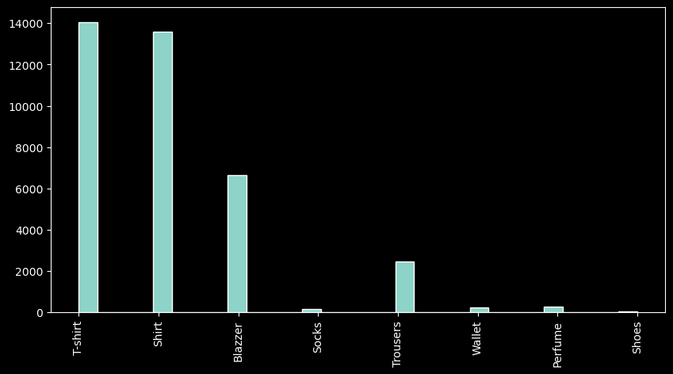

The graph clearly indicates a strong customer preference for the "T-shirt" category. This finding underscores the high demand for T-shirts among customers. Businesses should consider optimizing their product offerings, marketing efforts, and inventory management to cater to this consumer trend and potentially boost sales in this category.

Pie chart of B2B Data

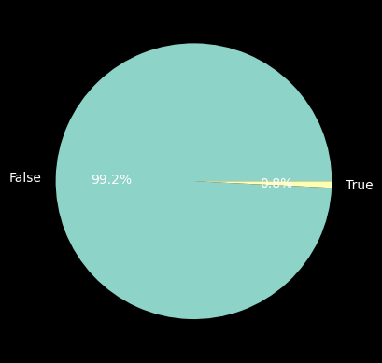

The pie chart reveals a substantial market presence of retailers, comprising 99.2% of the customer base, while B2B buyers represent a smaller share at 0.8%. This distribution highlights the predominance of the retail sector and suggests that business strategies should primarily target this customer segment to maximize sales and revenue.

Scatter plot of category and size

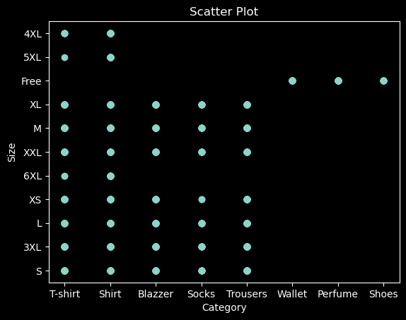

The scatter plot illustrates that T-shirt and shirt sizes are consistently unavailable, indicating a potential gap in inventory management. On the other hand, sizes for items such as socks, trousers, wallet, perfume, shoes, and blazers appear to be readily available.

Plot count of cities by state

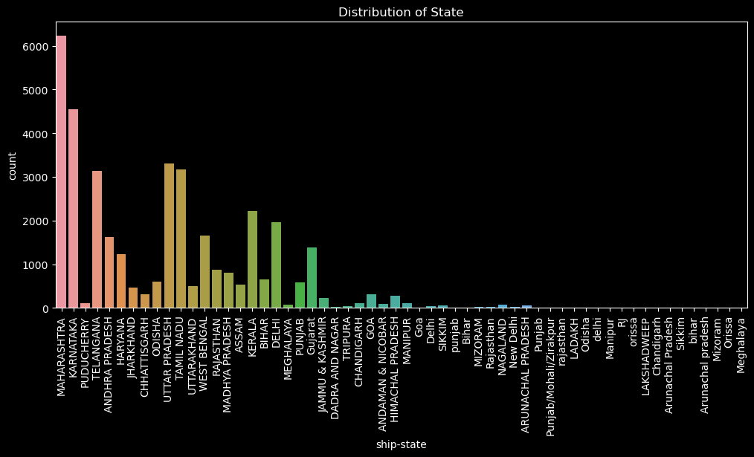

All states has present in this graph but , easten states are not showing well so I create top 10 state bar chart to analyse things clearly.

Top 10 states where majority of buyers are high

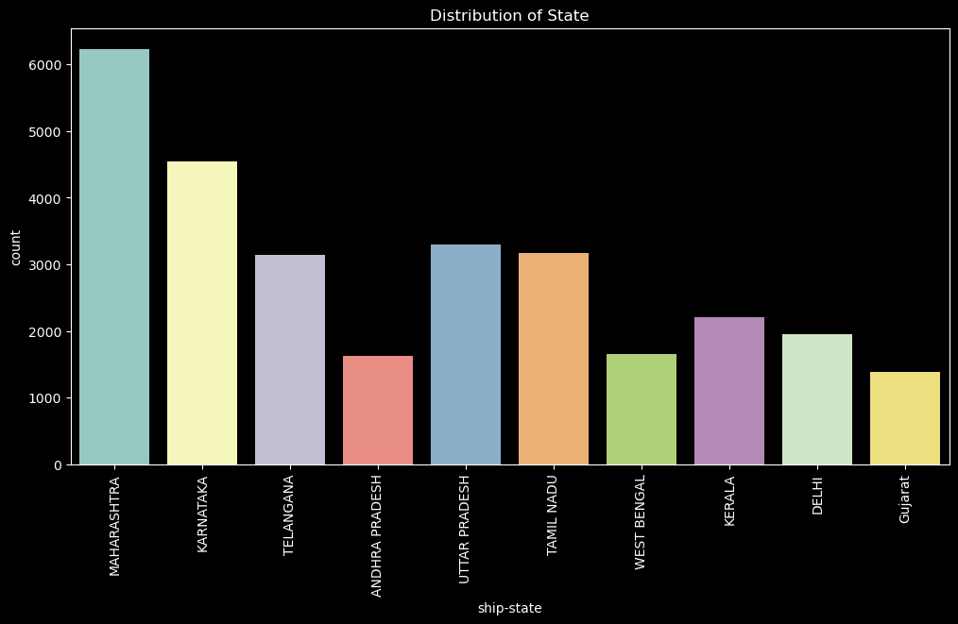

The data indicates that the majority of buyers are located in the state of Maharashtra. This concentration of customers in Maharashtra suggests the significance of tailoring marketing strategies and distribution efforts to capitalize on this strong regional presence, potentially boosting sales and market share in this state.

Conclusion :

the analysis highlights a clear customer preference for medium-sized clothing items, particularly T-shirts and shirts. Retailers dominate the market, underscoring the importance of tailoring strategies toward this sector. Addressing inventory gaps, particularly for T-shirts and shirts, is crucial. Additionally, focusing on Maharashtra due to its strong customer presence offers an opportunity for strategic market expansion. By adapting to these insights, businesses can optimize their offerings and marketing efforts to drive sales growth.

Suggestions :

**Market Research:** Regularly conduct market research to stay updated on industry trends, consumer preferences, and competitor strategies.

**Online Presence:** Enhance your online presence through a professional website and active engagement on social media platforms to reach a wider audience.

**Customer Service:** Provide excellent customer service to build a positive reputation and encourage repeat business.

**Quality Assurance:** Maintain high product or service quality to build customer trust and loyalty.